Utiliser le contrôle colorChoicer

Objectif :
Utilisable dans un formulaire, le colorChoicer se présente sous la forme d’un bouton coloré qui ouvre une palette quand on clique dessus :
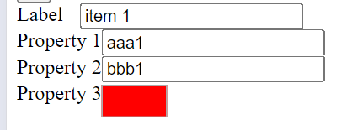
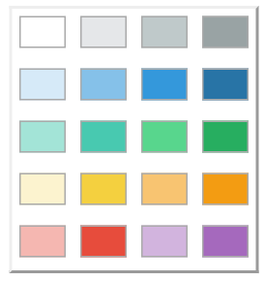

Mise en place :
Il faut veiller à inclure le fichier colorChoicer.js
<!DOCTYPE html>
<html>
<head>
<title>Form</title>
<meta charset="UTF-8"/>
<link href="css/jsa.css" rel="stylesheet" media="all" type="text/css">
<link href="css/multiDisplay.css" rel="stylesheet" media="all" type="text/css">
<link href="css/editor2.css" rel="stylesheet" media="all" type="text/css">
<link href="img/favicon.png" rel="icon" media="all" type="text/css">
<meta name="viewport" content="width=450, user-scalable=no">
<meta charset="utf-8">
<style>
</style>
</head>

<body>
<script src="js/jsa.js"></script>
<script src="js/jsa.cls.js"></script>
<script src="js/jsa.appliMobile.js"></script>
<script src="js/jsa.application.js"></script>
<script src="js/multiDisplay.js"></script>
<script src="js/form2.js"></script>
<script src="js/grid.js"></script>
<script src="js/formInput.js"></script>
<script src="js/formBlock.js"></script>
<script src="js/colorChoicer.js"></script>
<script src="js/tabs.js"></script>
<script src="js/selector.js"></script>
<script src="js/editor2.js"></script>
<script>
</script>
<script>
jsa.appliMobile({
id:"myOrganization",
label:"My organization",
objects:[],
displayBody:function(){
return {
tag:"div",
className:"appliMobile_body",
owner:this,
isElt:"_divBody",
children:[{
tag:"form2",
fields:[
{tag:"formInput", id:"label", label:"Label", type:"string"},
{tag:"formInput", id:"prop1", label:"Property 1", type:"string"},
{tag:"formInput", id:"prop2", label:"Property 2", type:"string"},
{tag:"colorChoicer", id:"prop3", label:"Property 3", type:"string", possibleColors:[
["", "#e5e7e9", "#bfc9ca", "#99a3a4"],
["#d6eaf8", "#85c1e9", "#3498db", "#2874a6"],
["#a3e4d7", "#48c9b0", "#58d68d", "#27ae60"],
["#fcf3cf", "#f4d03f", "#f8c471", "#f39c12"],
["#f5b7b1", "#e74c3c", "#d2b4de", "#a569bd"]
]}
],
record:{tag:"tag1", id:1, label:"item 1", prop1:"aaa1", prop2:"bbb1", prop3:"red"}
}]
};
}
});

appli.mobile=true;
appli.smallScreen=false;
</script>
</body>
</html>

